Communication network
- Upward Communication : This may be defined as information that flows from subordinates to superiors. Some of the reasons for upward communication include discussing work related problems, giving suggestions for improvement and sharing feelings about the job and co-workers.
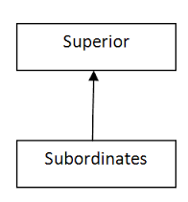
- Downward Communication: This may be defined as information that flows from superiors to subordinates. The most common reasons for downward communication are for giving job instructions, explaining company rules, policies and procedures and giving feedback regarding job performance. A number of studies have indicated that regular downward communication in the form of feedback given to employees is the most important factor affecting job satisfaction.
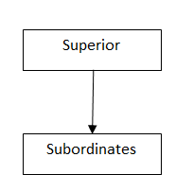
- Horizontal Communication: This type of communication is also known as “lateral” communication. It may be defined as communication that takes place between co-workers in the same department, or in different departments, with different areas of responsibility. For example, Sales Managers and Advertising Managers in the Marketing department, or Marketing Managers and Finance Managers.

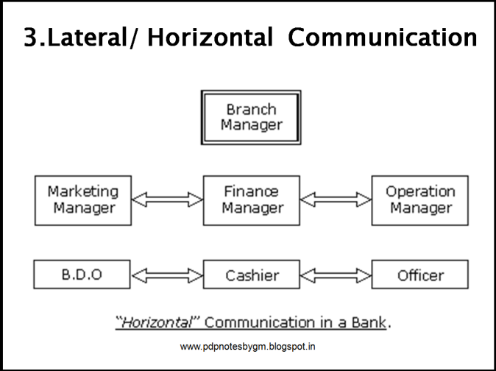
- Spiral or diagonal comm : Diagonal communication refers to communication between managers and workers located in different functional divisions

GRAPEVINE : Informal communication is also known as grapevine communication because there is no definite route of communication for sharing information. In this form of communication, information converges a long way by passing from one person to another person leaving no indication from which point it started.
Advantages :
- Flexibility: Informal communication is more flexible than formal communication because it is free from all type of formalities.
- Rapid communication: Informal communication transmits very fast. Especially miss-information or rumour spread rapidly to others in the organization.
Disadvantages :
- Distort meaning: Something the meaning and the subject matter of the information is distorted in this system.
- Spread rumour: In this system, the miss-information or rumour spread rapidly. The original information may be transformed to wrong information.
- Misunderstanding: Under this system, generally, the employees do not obey the formal authorization system. So it creates the opportunity to develop misunderstanding.
- Maintaining secrecy is impossible: In informal communication system maximum communication is made by open discussion. So it is impossible to maintain the secrecy of the information.
- Difficulty in controlling: Under informal communication system no established rules or policy is obeyed. So it is very much difficult to control the information.

Tips of effective internal comm.
- Ensure that every employee receives a copy of the strategic plan.
- Develop a basic set of procedures
- Regularly hold management meetings
- Leaders and mangers should have one-to-one meetings with employees periodically
- Ensure that all employees receive yearly performance reviews , including their goals , updated job description etc
Communication barriers
A. Physical barriers
Internal structure of the organization and layout of office machines and equipments creates physical barriers in communication
a. Distance: – communication is found obstructed in long distance. Like communication between America and Nepal.
b. Noise: – it is from external sources and affects the communication process. Noise negatively affects the accuracy
c. Physical arrangement: – the physical arrangement of organizational sources like men, money, material and machine obstruct the communication process.
B. Semantic barriers
The use of difficult and multiple use of languages, words, figures, symbols create semantic barriers.
a. Language: – we can find some words having different meaning. As meaning sent by the sender can be quite different from the meaning understood by the receiver. Long and complex sentences creates problem in communication process.
b. Jargons: – technical or unfamiliar language creates barriers to communication that may be drawn from the literature. So message should be simple and condensed as far as possible so that no confusion creation will be there to the receiver.
C. Organizational barriers
It is raised from the organizational goals, regulations, structure and culture.
a. Poor planning: – it refers to the designing, encoding, channel selection and conflicting signals in the organization.
b. Structure complexities:- difficult organizational structure barrier for free flow of information. Appropriate communication process must be used.
c. Status differences: – it creates barrier for communication. Superior provides information to the subordinate about plans and policies. Different information is provided by different subordinates who create barrier in communication.
d. Information overload: – if superior provides too much information to the subordinate in short period receiver suffers from information overload which creates barriers to effective communication.
f. Timing: – communication can be obstructed if not done on time. If the information is not provided in time it creates barriers to effective communication.
D. Psychological barriers
It is the barriers to effective communication created from the lack of interest of the people from whom the communication is meant. People do not pay attention to the communication which are not interesting to them and which do not fulfill their want.
a. Perception: – it is the process of accepting and interpreting the information by the receiver. People receive things differently for a various number of reasons.
b. Filtering: – communication some time filters the negative information to make it more favorable to the receiver. In this process, knowingly or unknowingly some valuable information may be disposed.
c. Distrust: – superior provides information or message to the subordinates to their own view, ideas and opinion which create obstruction in communication.
d. Emotions: – emotion also creates barriers to effective communication like anger, het, mistrust, jealousy etc.

Types of nonverbal comm
TYPE | DESCRIPTION
Kinesics | Facial expression , posture and gestures:  The word kinesics comes from the root word kinesis, which means “movement,” and refers to the study of hand, arm, body, and face movements.
Oculesics | Eye contact. We also communicate through eye behaviours, primarily eye contact. While eye behaviours are often studied under the category of kinesics, they have their own branch of nonverbal studies called oculesics, which comes from the Latin word oculus, meaning “eye.”
Haptics | Communication of touch
Proxemics | Proxemics refers to the study of how space and distance influence communication. For example, when we are content with someone, we say we are “close” to him . When we lose connection with someone, we may say he is “distant.”
Apperance | Attire , jewellery , perfume , accessories
Vocalics | Vocalics is the study of paralanguage, which includes the vocal qualities that go along with verbal messages, such as pitch, volume, rate, vocal quality.
Chronemics | Chronemics refers to the study of how time affects communication. Time can be classified into several different categories, including biological, personal, physical, and cultural time

Cross cultural comm:
- Cross cultural comm. Looks at how people from differing cultural background endeavour to communicate.
- Misunderstandings and misinterpretations are probably the most common problems people face.
- Ethnocentrism It is the tendency to look at the world primarily from the perspective of one’s own tradition.
- For eg : an Indian employee in UK may bow slightly to greet his manager , who may pass a mocking comment.
- Similarly Chinese people looking for chopsticks in foreign countries may feel embracing .
- We often tend to judge others in terms of our experience note their context.
- We fail to understand that their ways have their respective meaning and function in life , just as our ways have for us.
Cultural variables
- FOOD
- EDUCATION
- LAWS AND REGULATIONS
- RELIGION
- TECHNOLOGY
- LANGUAGE
- DRESS
- DECISION MAKING : (in some culture it is collective decision making as in Japan , while in other America is individual

Cross cultural strategies
- Don’t jump to conclusion immediately .
- Sometimes words are used differently between languages or cultural group. So prior knowledge is required..
- Take the aid of intermediaries if required
- Direct experience is the best way to begin to understand any culture
- Avoid exaggeration .
- Updating one’s knowledge of different cultures is very crucial.
Technology- enabled business communication : (assignment number 1)
- Telephone and voice mail
- Mobile
- Facsimile machines
- Computers
- Internet
- email
- Conferencing
- Video
- Audio
- Web
Netiquette : It means acceptable behaviour and usage of the internet in a safe way.
- Following points should be met:
- Use proper naming conventions
- Most of the information is receive by www.abc.com site but don’t necessarily rely on them.
- Do not assume that any information is upto date and accurate
- Respect the copyright material and use in proper way.
- Do not flourish your personal information without the guarantee of security
Positive impact of technology.
- Distance no longer a barrier
- More people have access to information
- Time required to make decisions decreased
- Managers can get accurate data at faster pace
- Whole organisation can be linked

Negative impact
- Information overload
- People isolation
- Less time for organisation activities.
- Network errors effect the performance .

Selection of appropriate tech. or factors affecting choice of tech.
Technology | Nature  Of message | Speed of establishing  connection | Time to get feedback | Receiver’s  Attention | permanency
Email | Formal /  Informal | Fast | Delayed | Low | Yes
Fax | More formal | Fast | Delayed | Low | Yes
Telephone | Formal /  Informal | Varied | Immediate | High | None
Video conf. | formal | slow | Immediate | High | Possible
Voice mail | Mostly  Personal | Fast | delayed | low | possible

